## **cnf-prod-db-01**

CNF_BITV5_BACKUP

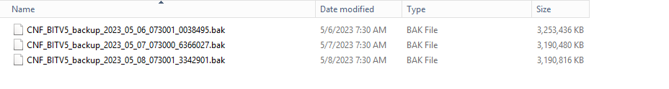

CNF_BITV5_IdentityServer-Backup



**cnf-prod-app-01**

Backup

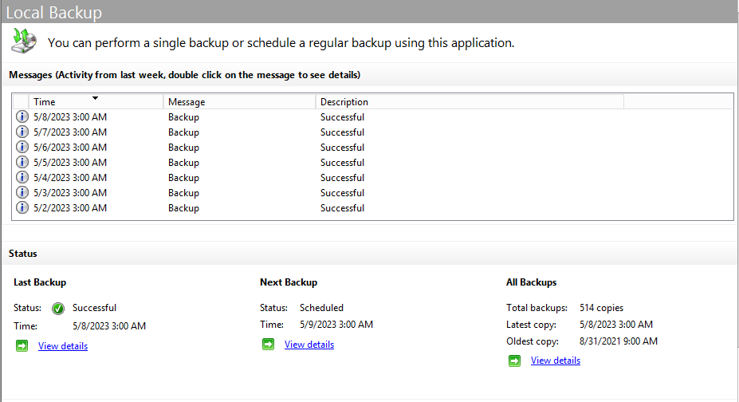

## 

## **cnf-prod-app-02**

Backup

